Strategic Equality Plan Annual Report
1st April 2020 to 31st March 2021

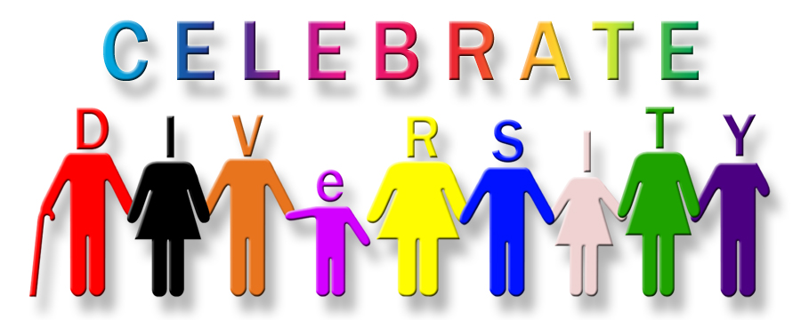

Should you require this document in an alternative format or if you have any queries relating to this report, please contact:

Tel: 01685 726198 or Email: l.lloyd@merthyr.ac.uk

1. Introduction and background

Under the Equality Act 2010 (Statutory Duties) (Wales) Regulations 2011 the College, as a public authority, is required to develop a Strategic Equality Plan (SEP) and publish an Annual Report by the 31st March each year. The report must cover the period of 1st April to 31st March of the previous year.

The SEP Annual Report must detail:

- the steps we have taken to identify and collect relevant information;
- how the information has been used to meet the aims of the public sector duty;
- the reasons for not collecting relevant information;
- a statement on the effectiveness of the arrangements for identifying and collecting relevant information;
- progress towards fulfilling each of our equality objectives;
- a statement on the effectiveness of the steps we have taken to fulfil each of our equality objectives;
- specified employment information

The College Merthyr Tydfil is part of the University of South Wales (USW) Group. For the purposes of equality, diversity and inclusion (EDI), the College is included within the Group’s Strategic Equality Plan (SEP) 2020-2024, but reports separately for the Annual Report. This particular Report covers the period 1st April 2020 to 31st March 2021. The University and the Royal Welsh College of Music & Drama (also members of the USW Group) each report separately.

Details of strategic objectives and progress towards meeting them is outlined in Appendix 1, a detailed table of progress. Appendix 2 contains the specified EDI employment information required; Appendix 3 contains the EDI statistical data of the learner population for this period.

2. Equality at The College Merthyr Tydfil

The EDI agenda at the College sits within the remit of the Vice Principal Resources. The operational remit is the responsibility of the Head of Wellbeing & Learner Support Services
College staff attend the University Equality & Diversity Steering Group (EDSG), which meets termly and has representation from all departments, faculties, trade Unions, Students’ Union and The Royal Welsh College of Music and Drama. The group considers all equality issues and protected characteristics, oversees compliance with the Equality Act 2010 and provides strategic direction for the USW Group’s equality agenda. EDSG has overarching responsibility for the implementation and review of the SEqP.
In addition to EDSG, the USW Group has equality sub groups that are responsible for progressing the equalities agenda for specific protected characteristics. All equality sub groups meet termly, feed into EDSG and are chaired by senior colleagues.

3. Identifying, Collecting & Using Relevant Information

3.1 The Steps Taken to Identify and Collect Relevant Information

Under the Equality Act statutory duties for Wales, equality monitoring data of staff and learners is classed as ‘relevant information’ to support the Strategic Equality Plan.
The college uses the same online recruitment and HR system as USW and monitors all protected characteristics of staff. Applicants are able to input their equalities data confidentially as part of the application process. This enables the recruitment system to produce yearly reports on the success rate of candidates through all stages of the recruitment process anonymously by protected characteristics.
The HR system contains a ‘self-service’ option for existing staff to provide their own equality data, if they have not done so through recruitment.
Learner enrolment takes place in August and September in each academic year through an online system which includes equality monitoring for all protected characteristics. This data is stored securely and used anonymously to report on learner populations of equality groups. This information is presented to the college Senior leadership Team (SLT) and Board of Directors each year for analysis and scrutiny. The Strategic equality plan 2020/2024 has clear actions to strengthen the use of learner equality data to assess and develop plans which support the diversity of the learner body and their experience.

3.2 How the institution has used this relevant information to meet the three aims of the public sector duty

All actions within the USW Group’s Strategic Equality Action Plan have been developed based upon relevant information gathered through consultation and engagement and detailed analysis of staff and learner data, in addition to other relevant equalities information.
It should be noted that the College has its own Strategy Equality Plan for 2020 – 2024. The USW Group's eight Strategic Equality Objectives, along with the detailed Strategic Equality Action Plan that underpins these objectives, all focus upon meeting the three aims of the public sector duty:
- Eliminate unlawful discrimination, harassment and victimisation
- Advance equality of opportunity between different groups
- Foster good relations between different groups
Equality information gathered is used to monitor implementation of the duties and, where relevant, features in the Action Plan – Report on Progress (Appendix 1).
The College Merthyr Tydfil is included in the University’s Equal Pay review, the first of which took place in 2020/21. It is inclusive of the characteristics of Disability, Gender & Age, Ethnicity, Sexual Orientation, Religion and or Belief, with full consideration of both mean and median pay gaps. The findings were published in May 2020 with a full set of recommendations across the protected characteristics underpinned by the action plan.

3.3 Reasons for Not Collecting Relevant Information

The college collects all protected characteristics for staff and learners, with the exception of Pregnancy and Maternity and Marriage and Civil Partnership.

Pregnancy and Maternity
Information on pregnancy/ maternity for learners is not collected during enrolment. However, the college supports learners as and when required through the Wellbeing & Learner Support Services team, the I2A team and the Nurse Practitioner. Our HR function holds information on staff pregnancy/ maternity to administer maternity leave.

Marriage and Civil Partnership
Data on marital and civil partnership status is collected for staff, but not learners as this is not a protected characteristic for FE and there are no plans to introduce monitoring of this characteristic for learners. The gender-neutral title ‘Mx’ is available for both staff and learners.

3.4 Statement on the Effectiveness of Arrangements for Identifying and

Collecting Relevant Information

Significant efforts are made to identify, collect, analyse and use relevant information. The arrangements in place for this are being developed, reviewed and revised regularly.
USW’s robust equality governance structures ensure that there is specific focus on equality and inclusion priorities.

4. Strategic Equality Objectives – Progress Report
In line with our statutory duties, Appendix 1 provides details of progress we have made towards fulfilling our equality objectives for 2021/2021 as outlined below:

OBJECTIVE 1 - We will build a culture of inclusion by promoting dignity, respect, fairness and wellbeing within the University and College communities.

OBJECTIVE 2 - We will mainstream equality, diversity and inclusion into University and College decision-making, policies, practices and procurement.
OBJECTIVE 3 - We will embed equality, diversity and inclusion into the design and delivery of our curriculum, courses and assessment methods.

OBJECTIVE 4 - We will extend our attractiveness as a university and college of choice for students and colleague from diverse backgrounds, cultures and identities.

OBJECTIVE 4 - We will extend our attractiveness as a university and college of choice for students and colleague from diverse backgrounds, cultures and identities.
OBJRCTIVE 5 – We will work to increase the accessibility of our IT systems, physical environments and communications.
OBJECTIVE 6 - We will take action to reduce the pay gaps at USW and The College. (These actions are also USW’s Gender Pay Action Plan).

5. Conclusion

This report reflects progress during the first year of the USW Group’s Strategic Equality Plan for 2020 to 2021, as it pertains to the College Merthyr Tydfil. The college, in conjunction with USW, FE partners and 3rd sector partners where appropriate, continues to work towards fulfilling the Group’s six strategic equality objectives.

The advent of the Covid_19 Pandemic and the subsequent effect on a drastically altered landscape, had a significant impact on teaching and learning, with an unprecedented scale of change.

This report has highlighted the achievements during this period, along with areas that require additional focus.

Lynne Lloyd
Head of Wellbeing and Learner Support

Appendix 1: Action Plan – Report on Progress
Appendix 2: EDI Staff Statistics

