Policy on the use of Welsh at The College Merthyr Tydfil

April 2021
Policy originator: Bilingual Officer

Equality Impact Assessment Completed:

Approved by: College Executive
Approval Date: April 2021

Review Date: April 2023

Policy on the Use of Welsh at the College
Purpose and Objectives
1. Scope
2. Service Delivery
3. Internal Operations
4. Policy Making
5. Monitoring and Reporting
6. Dealing with Supplementary Matters

Purpose and Objectives – Section A
The College Merthyr Tydfil fully supports the use of Welsh in the workplace. The aim of section A in this policy is to provide guidance to all staff on the use of Welsh in the College whilst also ensuring compliance with the requirements of the Welsh Language Standards introduced under the Welsh Language (Wales) Measure 2011. The Welsh Language Standards specify how public organisations in Wales are expected to use the Welsh Language in their day-to-day business and in their delivery of services.
The implementation of this policy is in line with the requirement of Standard 105 of the Welsh Language Standards. The College is aware of the pivotal role it has to play with regards to the Welsh Government’s target of creating a million Welsh speakers by 2050 and to double the number of people who use Welsh on a daily basis. https://gov.wales/cymraeg-2050-welsh-language-strategy

The objectives of this policy include:

- Raising awareness of how the Welsh language is used and promoted in the college
- Facilitating Welsh cultural, historical and socio-economic awareness activities
- Increasing the use of Welsh in the college
- Encouraging and offering staff every opportunity to learn and improve their Welsh language skills

The College Merthyr Tydfil strategic objectives (alongside the Welsh Language Standards)

In addition to meeting the Welsh Language Standards statutory requirements the College has developed a Welsh medium and Bilingualism Strategy and Action Plan which underpins the college’s Vision, Mission and Strategic Plan 2023 and the overall aims and objectives set out in the Coleg Cymraeg Cenedlaethol’s Towards Cymraeg 2050: A million Welsh speakers – Further Education and Apprenticeship Welsh-medium Action Plan

1. Scope
1.1 This policy will provide a strong foundation for the Welsh services provided by the College to its staff, learners and the public, and will reinforce the compliance requirements of the Welsh Language Standards.
1.2 The College will continue to implement its Linguistic Skills Strategy and will keep a record of the language levels of staff and learners, allowing staff the opportunity to update CPD records as they develop their Welsh language skills and allowing all learners to develop their skills through a variety of development programmes. The College will keep a record of the language choice of staff on the INTERNAL HR system and a record of the language choice of all learners through the EBS system.
1.3 All College Managers will have a good understanding of the requirements of the Welsh Language Standards and will play a practical role in promoting the commitments of this Policy when promoting the use of Welsh in the workplace.
1.4 Further information about the Welsh Language Standards that the College needs to comply with can be found here: https://www.merthyr.ac.uk/en/the-college/welsh-language-standards/
1.5 Any enquiries regarding the Welsh Language Standards or this policy should be referred to Lynwen Harrington at l.harrington@merthyr.ac.uk
2. Service Delivery
2.1 Service Delivery: Written Correspondence
2.1.1 The College welcomes correspondence from staff, learners and members of the public in Welsh or English. Correspondence received in Welsh will be replied to in Welsh. All correspondence, be it in Welsh or English, will be replied to within the same timescale.
2.1.2 The College keeps a record of the language choice of staff, learners and their parents/guardians at the beginning of each academic year. Those who have expressed the preference will receive all future correspondence in Welsh.
2.1.3 Standard/generic emails, letters and newsletters are issued bilingually.
2.1.4 All internal college emails to staff from the Welsh Team are issued bilingually.
2.1.5 The College is committed to ensuring that correspondence through the medium of Welsh will not lead to delay in receiving a reply. The College employs a part time translator who is able to provide an efficient service and quick turnaround time for translation and proofreading requests. Be aware this is applicable for term time only. Out of term requests will be external translators only with the minimum of 10 working days’ notice.
The standard timescale for translation is:
- Up to 2 sides of A4 (1000 words) – 1 working day
- Between 2 – 5 A4 sides (2500 words) – up to 5 working days
- Between 5 – 10 A4 sides (5000 words) – up to 10 working days
- More than 10 A4 sides will be externally translated with the minimum of 15 working days’ notice.
To enable the translator to complete your request you must submit the following:
- The final draft only (no subsequent amendments after submission).
- Editable format for example, Word, PowerPoint, Excel, Publisher. (No PDF, screen shots or any bespoke artwork).
- State the date that the translation is needed by (following the above timescale conditions)
2.2 Service Delivery: Telephone Services
2.2.1 All incoming calls are answered with an initial bilingual greeting.

2.2.2 Answerphone messages carry a short bilingual message and callers are welcome to leave a message in either Welsh or English. The response to the caller’s message will be in the caller’s preferred language choice.

2.2.3 The College is fully committed to increasing the number of Welsh speaking staff members in front-facing (public facing) roles, as such roles become vacant and depending on the capacity of Welsh-speakers or learners applying for such positions.
2.3 Service Delivery: Meetings, Open Evenings and Presentations
2.3.1 Meetings with individuals.
Staff have the right to use Welsh in meetings in relation to the following, and the College will make the appropriate arrangements throughout the process:
- Performance Management
- Complaints
- Disciplinary matters
- Consultations on the restructuring of a department or service
- Job interview
If the persons responsible for holding the meetings above cannot do so in Welsh then arrangements will be made so that another appropriate Welsh speaking member of staff can do so. Where this is impossible or in situations where it would be inappropriate, a simultaneous translation service will be provided. The Management Team will be responsible for organising simultaneous translation.
2.3.2 College wide and other group meetings
If an invitation is issued to all members of staff to attend a particular meeting or a special meeting (e.g. Consultation meetings) staff will have the right to use Welsh in that meeting. Simultaneous translation will be provided to facilitate this. The Principal’s Office will be responsible for organising simultaneous translation.
2.3.3 All public meetings will be advertised bilingually.
2.3.4 The College will ensure there are staff members that will meet and greet bilingually
2.3.5 The College will provide simultaneous translation in public meetings if attendees have expressed their wish to undertake the meeting through the medium of Welsh.
2.3.6 College Managers and staff will make every effort to use bilingual presentations and incidental Welsh at all internal and public meetings.
2.3.7 Where an individual has expressed the preference to communicate through the medium of Welsh, the College will ensure there is a Welsh-speaking member of staff present to facilitate communication.
2.3.8 Questionnaires and/or surveys aimed at staff, learners or the public will be available bilingually or in Welsh and English. The anonymity of respondents, whether responding in Welsh or English, will be protected.
2.4 Service Delivery: Electronic Communications
2.4.1 People wishing to communicate via e-mail are welcome to use either Welsh or English, and the College will respond in the language of the initial message while ensuring there is no delay in responding.
2.4.2 Staff e-mail signatures are bilingual and Welsh-speaking staff members are encouraged to display the “Work Welsh” logo to identify themselves as Welsh speakers.
2.5.2 Staff are expected to use the guidelines on ‘how to create a bilingual message’ as issued on the staff Portal when activating ‘out of office’ email messages.
2.5 Service Delivery: Branding and Public Identity
2.5.1 The College publishes all corporate material bilingually.
2.5.2 The College’s corporate identity is bilingual.
2.5.3 The College ensures that the format, quality, size and prominence of the Welsh and English languages will be equal on all corporate materials.
2.5.4 Where there is the need for separate Welsh and English versions of a document/publication, both versions are published and distributed simultaneously. Welsh and English versions will be of the same standard and displayed together. In these instances, each version will carry a statement explaining that the document is also available in the other language.
2.5.5 The College logo and College templates are available bilingually and ensure that both languages are treated equally.
2.5.6 College staff and external stakeholders are provided with guidance on how to deal with bilingual publications and separate Welsh/English versions of publications. The college also has a clear flow chart to support and remind staff about the procedure for publication of documents.

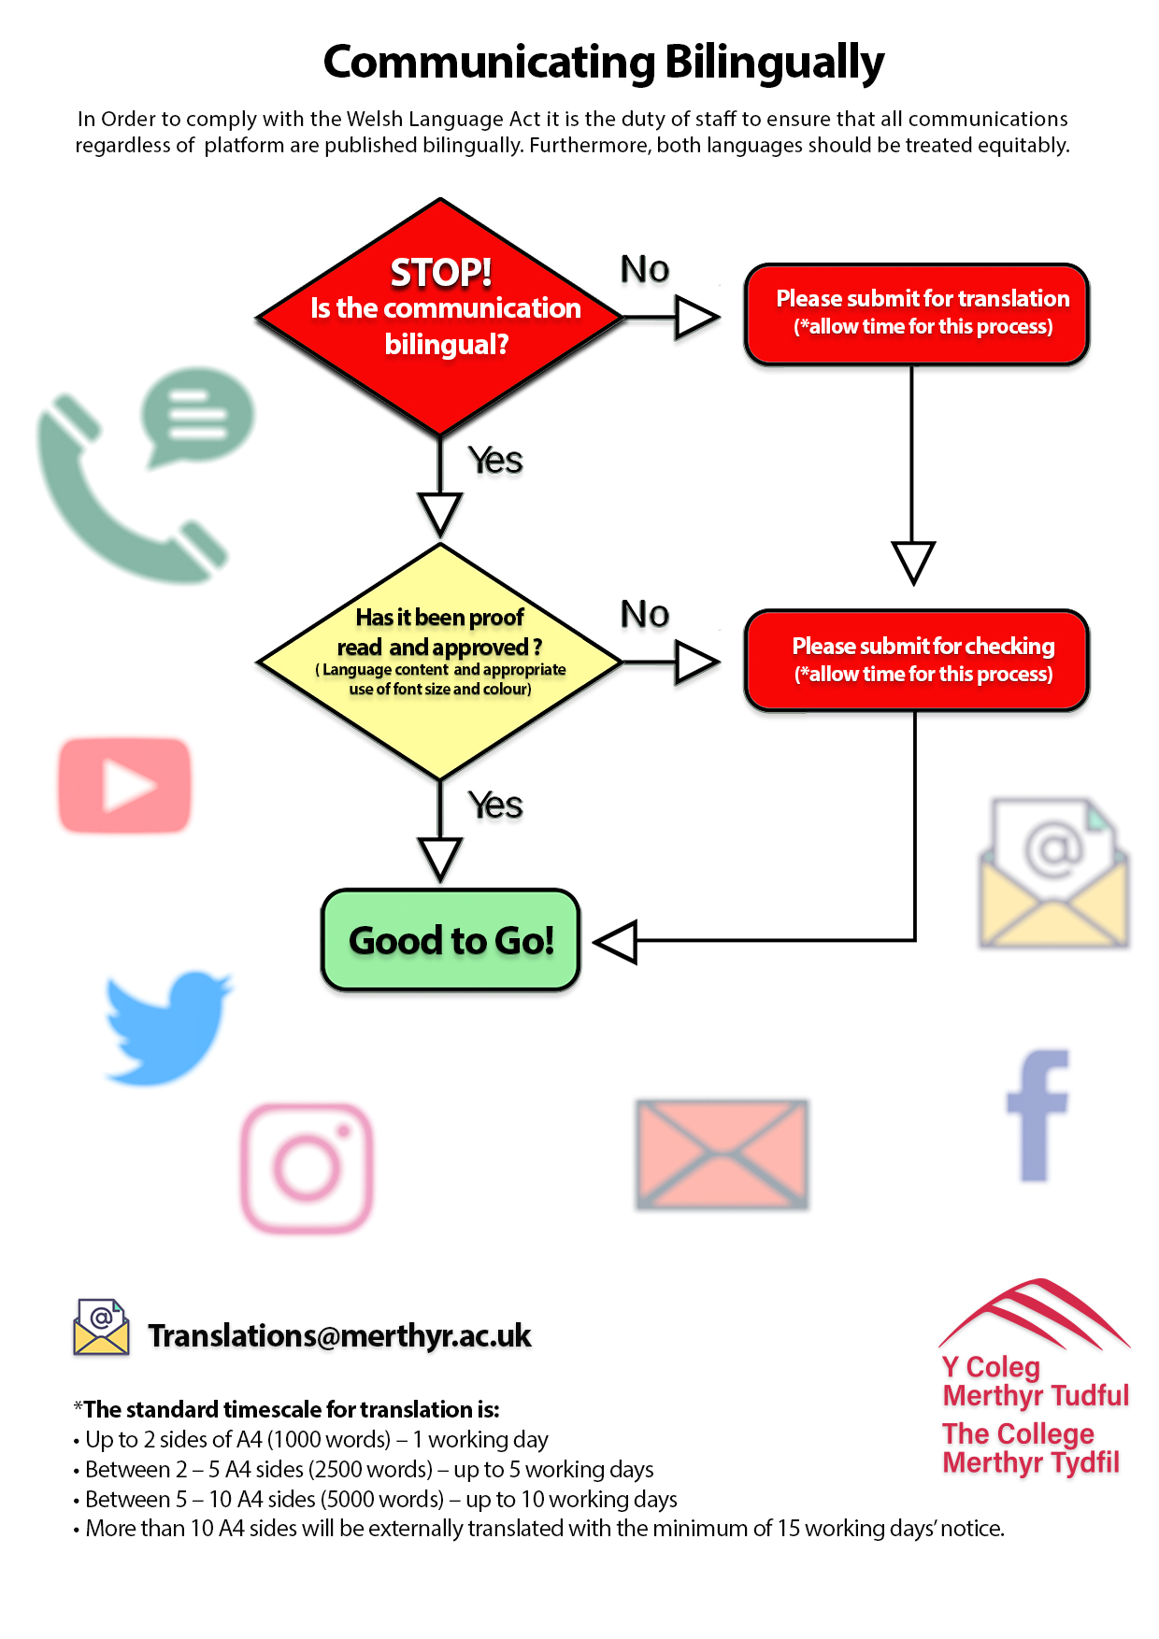

2.5.7 All College forms are available bilingually.
2.5.8 All College written, and electronic material aimed at the public is published bilingually, or in Welsh and English. Again, the College will ensure that the format, quality, size and prominence of the Welsh and English languages will be equal on such materials.
2.5.9 All College publicity material is issued bilingually and designed to treat the Welsh and English languages equally.
2.5.10 All College exhibition material is available in Welsh and English, or bilingually, and will treat both languages equally.
2.5.11 All College’s public notices and adverts appear in Welsh and English and will treat both languages equally in terms of format, quality, size and prominence.
2.5.12 Social media notices are posted in Welsh and English, or bilingually, and will treat both languages equally.
3. Internal Operations
3.1 Internal Operations: Staffing and Recruitment
3.1.1 The College undertakes an audit of Welsh speakers within each Teaching and Learning and Business Support area, and highlights areas where the need for staff members with Welsh language skills is deemed as “Essential” or “Desirable” in relation to the nature of the post and Welsh Government priorities.
3.1.2 All College employees are required to self-assess their Welsh linguistic skills in Speaking, Listening, Reading and Writing on a bi-annual basis.
3.1.3 For appointments to a role where the ability to speak or write in Welsh is considered as an essential skill in the job description, the level of proficiency in both English and Welsh is tested at interview.
3.1.4 Interviews for jobs advertised as Welsh essential should be carried out through the medium of Welsh. Where possible all members of the interview panel should be Welsh speaking. Where there is a mixture of Welsh speaking and non-Welsh speaking staff on the interview panel simultaneous translation facilities should be used throughout the interview.
3.2 Internal Operations: Induction, Staff Development and Training
3.2.1 All new members of staff undertake an Initial Induction Session, which includes a session on Welsh Language and Culture in the College, an overview of the Welsh Language Standards, how Welsh can be used in the workplace, information about Welsh language courses and guidance on where to find assistance on the Staff Portal in relation to translation services and All Things Welsh at the college.
3.2.2 All staff should complete the Welsh Language Awareness training module as part of the mandatory suite of cross college CPD.
3.2.3 All staff are encouraged to undertake Welsh Language training. Staff have the right to attend Welsh language classes for free, from beginner’s level to advanced level. The Management Team will develop a guideline for all line managers to enable staff to attend classes during working hours.
3.2.4 Teaching staff are encouraged to undertake tailored Welsh language courses (e.g. Cymraeg Gwaith project) which include a mentoring and coaching element.
3.2.5 Progress and development of staff individual Welsh language skills should be discussed as part of the Personal Development Plan (Appraisals).
3.2.6 All mandatory training for staff will be available in Welsh including:
- Language awareness
- Health and safety
- Equality and diversity
- Safeguarding
3.2.7 For Leaders and Managers the following training will be available in Welsh:
- Recruitment and interviewing
- Performance management
- Complaints and disciplinary procedures
- Using Welsh effectively in meetings, interviews
3.2.8 When an external provider is used to provide internal training, the College will consider the importance and relevance of providing the training in Welsh (if different to those listed above). As part of the tendering process, and in accordance with the requirements of Standards 80-84, the College will request information regarding a third party’s ability to provide training services in Welsh and every effort will be made to hold a corresponding course in Welsh. The external provider will be responsible for arranging and paying for translation and providing Welsh speaking facilitators where necessary.
3.3 Internal Operations: Translation
3.3.1 All staff members have access to the College’s internal translation service and are advised on how to use this service appropriately.
3.3.2 During periods of demand, which exceed the capacity of the in-house translation facility, the College will use an external translator on the advice of the College’s full time Translator.
4. Policy Making
4.1 Policy Making: Policies and New Initiatives
4.1.1 The College monitors all new policies and initiatives to ensure they are consistent with the Policy on the Use of Welsh and are compliant with the Welsh Language Standards.
4.1.2 All new policies and initiatives are scrutinised as part of the Impact Assessment process, to assess their possible linguistic implications and to ensure there is no negative impact on the Welsh language.
4.1.3 All staff who are responsible for creating policies and new initiatives should be aware of the Policy on the Use of Welsh and of the requirements of the Welsh Standards Compliance.
4.1.4 When creating new policies and initiatives the College will endeavour to promote, encourage and develop the Welsh language and ethos.
4.2 Policy Making: Tenders
4.2.1 When the College invites tenders for specific contracts, consideration of linguistic trends and requirements are made and communicated in the tender specification; the monitoring of sub-contractors includes reference to their performance in relation to Welsh considerations.
4.2.2 If the College receives a tender in Welsh, arrangements will be made for tenderers wishing to use the Welsh language in an interview or presentation.
4.2.3 The College promotes the Policy on the Use of Welsh with stakeholders and other establishments not compliant with the Welsh Language Standards, and will encourage them to adopt our processes for compliance.
4.2.4 If the College partakes in third-party arrangements, it will endeavour to establish that any such-contracts are consistent with our Policy on Use of Welsh and the Welsh Language Standards.
5. Monitoring and Reporting
5.1 The College undertakes a regular audit of Teaching and Learning and Business Support areas’ compliance with the Welsh Language Standards. Teaching and Learning and Business Support Managers should take responsibility for implementing the Welsh Language Standards on a local level.
5.2 Advice and guidance on the day-to-day adherence to the College Policy on the Use of Welsh, and compliance with the Welsh Language Standards is the responsibility of the Student Services and Welsh Manager supported by the Welsh Team.
5.3 The College Principal has overall responsibility for the above.
5.4 The College operates a Welsh Language Steering Group, consisting of representation from Curriculum and Business Support areas from across the College. The Welsh Language Steering Group is chaired by the College’s Assistant Principal (Learner Journey) and meets once a term. This Group monitors the College’s performance against each of the Welsh Language Standards. The Welsh Language Steering Group members take responsibility for disseminating initiatives and guidance across all areas.
5.5 The College will undertake an internal ‘Mystery Shopper’ exercise which will form part of the internal monitoring of compliance and progress in relation to the Welsh Language Standards. The exercise will be undertaken on a termly basis. Members of the College’s Welsh Team will lead this activity. The results of activities will be reported to the Welsh Language Steering Group.
5.6 The Student Services and Welsh Language Manager produces an Annual Report on College activity and performance in relation to the Compliance Notice. The Annual Report is presented to the Board of Governors and College Management Team for review and subsequent approval, prior to publication on the College website and on the staff intranet. All staff members are made aware of its publication via the staff intranet.
6. Promoting and facilitating the Welsh Language
6.1 Promotion of Welsh language services to staff at the College is the responsibility of the Management Team supported by the Welsh Team and Marketing Team
6.2. Promotion of Welsh language services to learners at the College is the responsibility of the Teaching and Learning Teams, Student Services Team and supported by the Welsh Team and the Marketing Team
6.3 Promotion of Welsh language services to the public at the College is the responsibility of the Student Services Team, Welsh Team and Marketing Team.
6.4 Promotion of Welsh language services to apprentices and employers at the College is the responsibility of the Work Based Learning Team, Welsh Team and Marketing Team.

6.5 All staff are encouraged to show their ability to speak Welsh, either as a fluent speaker or as a learner by wearing a badge or lanyard and by displaying the orange ‘Cymraeg Gwaith’ logo as part of their e-mail signature.

6.6 The College will create a calendar of events to promote and to celebrate Welsh and bilingualism. The College will also acknowledge the contribution of Welsh speaking staff and learners who are learning Welsh (e.g. Annual Awards). Activities will also be held which bring Welsh speakers, staff and learners together to socialise in Welsh (e.g. Coffee mornings, Competitions, events).

