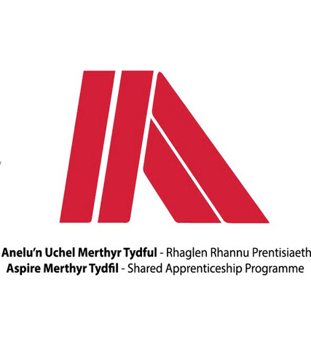
Name: | Thomas McKeown
Apprenticeship: | Engineering
Course: | Level 3 Enhanced Engineering

- What did you do before starting the apprenticeship?
Before I started my Aspire Apprenticeship I was doing college full time 5 days a week learning to get my level 3 BTEC manufacturing engineering qualification. This was so that I could get a job after I’ve got the qualification or I can get an Aspire Apprenticeship.

- Why did you apply for the scheme?
I applied for the scheme because I was always interested in having an Apprenticeship and after speaking to my tutors and being giving the opportunity to experience an Aspire Apprenticeship through work experience I thought it would be a good idea to go through this scheme so that I could get an apprenticeship that I would be successful in. When a maintenance Aspire Apprenticeship opportunity came up I jumped at the opportunity to be a part of it.

- What development opportunities have you had since joining? i.e. name of your course

Since I’ve been at the Aspire Apprenticeship Programme I have been given the opportunity to have real life experiences and gained a lot of knowledge throughout my process so far. With Aspire I’ve been given help and opportunities that may have been difficult to gain if I was to go through other means. They gave me the opportunity to be a part of my engineering maintenance apprenticeship.

- What has been your apprenticeship highlight so far?
So far my highlight would have been gaining my scissor lift and cherry picker licenses and this is because it had given me a totally different experience to what it’s like working on the ground and I really enjoy the new experiences that I am being given.

- Would you recommend an apprenticeship to others?
I would highly recommend an Aspire Apprenticeship to other people if they are thinking about getting into this line of work. You get the best help from everyone involved and you get the best experiences possible whilst being in a great environment and working with new people.

