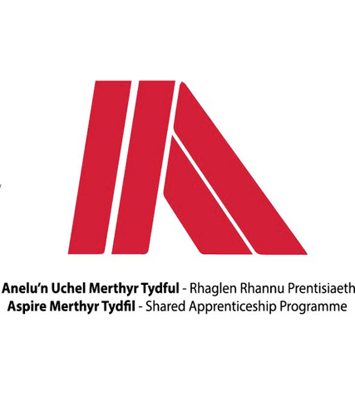
Name: | Cai Jones
Apprenticeship: | Engineering
Course: | Level 3 Enhanced Engineering

- What did you do before starting the apprenticeship?
Before starting my Aspire Apprenticeship I was enrolled at The College in Merthyr Tydfil studying Enhanced Engineering. This course was 5 days a week and full days. The main reasoning behind this course was that at the end of it you would get an Aspire Apprenticeship. This is the reason for me choosing. In between my leaving of College and start of my Job I had worked as a laborer and Shop floor operator for my current employers (Advanced Furniture).

- Why did you apply for the scheme?
The reason I had applied for the scheme is because I have a passion for engineering and knew that by going with Aspire they would be able to fulfill what I needed within regards to specific job roll types. When I was studying in college Tracy Jones had come in and spoken to us all within regards to what engineering route we wanted to go on. After her explaining all the different scenarios I knew that this was the route I wanted to take. Also, in my opinion I believe that an Aspire Apprenticeship is the best route you can take. You are not only getting the qualifications you need but also getting the hands on experience that is massively needed within this industry.

- What development opportunities have you had since joining MTCBC? i.e. name of your course
The pathway I took when joining the Aspire programme was mechanical and electrical engineering. I have now been working under this bracket for a year and feel as though I have become very competent in regards to my work and have a better understanding of all things engineering. Not only with practical work either, I have become a lot better at time keeping and ensuring that work is complete with regards to my NVQ work. With help from Gareth Etheridge from Tydfil Training, I now know that it is important to keep things up to date and ensure my work is done to a specific standard.

- What has been your apprenticeship highlight so far?
The highlight of my apprenticeship so far would be working on my own to do things I would have never thought I’d be able to do. For example, I am now undergoing tool changes on an injection molding machine unaccompanied. What this consists of is disconnect a 5 ton mould of steel from the injection molder, using a gantry to move it to its sitting location then attach another one and put this back in. This also involves programming the machine. When I first saw the programming section of this machine I did not understand any of it. But now time has gone on I am programming it to the specific settings needed for each tool. This to me is very fulfilling and leaves me very satisfied every time I successfully complete a tool change.

- Would you recommend an apprenticeship to others?
I would highly recommend an Aspire Apprenticeship to others. Not just in engineering but all ranges of Jobs. As I’ve said previously you are paid to learn. There is no better knowledge you could take than being in the working environment taking everything in when also getting qualifications that are needed

