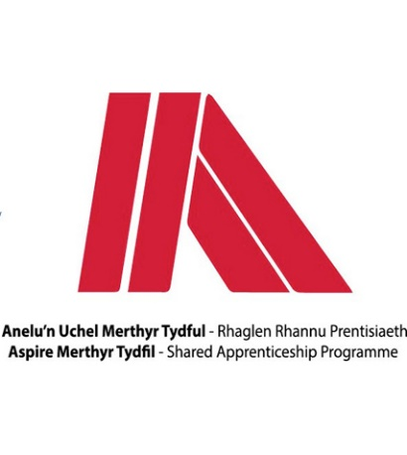
Name: | Ethan Williams
Apprenticeship: | Engineering –Welding
Course: | EAL Level 3 NVQ Extended Diploma in Fabrication and Engineering Welding

- What did you do before starting the apprenticeship?
I had a previous engineering job as a CNC machinist but it wasn’t an apprenticeship.

- Why did you apply for the scheme?
I applied for the scheme because I was invested in wanting an apprenticeship with qualifications at the end of it.

- What development opportunities have you had since joining MTCBC? i.e. name of your course
I am working towards a NVQ level 3 through a welding and fabrication qualification.

- What has been your apprenticeship highlight so far?
My highlight so far would have to be just meeting the other employees while learning about welding and fabrication.

- Would you recommend an apprenticeship to others?
Yes I would, just because at the end of it you have a qualification which can lead to other opportunities and look good for other employers.

