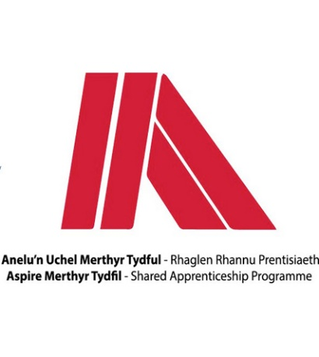
Name: | Talia Lewis
Apprenticeship: | Engineering (CAD)
Course: | EAL Level 3 NVQ Extended Diploma in Engineering Technical Support (CAD)

- What did you do before starting the apprenticeship?
Prior to starting my apprenticeship, I was a full-time student at Merthyr College completing my first year of Level 3 Engineering while working towards a Level 3 diploma in Advanced Manufacturing Engineering.

- Why did you apply for the scheme?
I applied for the Aspire Apprenticeship scheme as I was interested in completing my second year of college as an apprentice rather than a full-time student as I was looking to earn an income and gain an insight into the industrial sector while developing my skills both in a working environment and academically.

- What development opportunities have you had since joining MTCBC? i.e. name of your course
I have had a variety of developmental opportunities since joining the Aspire Programme. As I attend college 1 day a week, I have been working towards earning a Level 3 diploma in Advanced Manufacturing Engineering which allows me to develop myself in an academic environment. While at work I have begun working towards my NVQ Level 3 in Engineering Technical Support while working for my host company Abox Storage Solutions.

- What has been your apprenticeship highlight so far?
My apprenticeship highlight so far has been gaining an insight into the engineering industry, different types of machinery as well as how they operate. I have enjoyed learning from my colleagues who are more experienced.

- Would you recommend an apprenticeship to others?
I would recommend choosing the Aspire Apprenticeship route to others as I feel like an apprenticeship in the perfect compromise for individuals who are looking to improve academically while earning an insight into a career. I also think that an apprenticeship is a good option for people who are looking to earn an income while learning about an industry.

